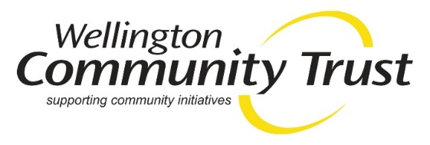

Impact of Government funding shortfall visible
Tuesday, September 3rd, 2019
The Wellington Community Trust regularly sees the impact of the Government’s underfunding of core social services in funding applications from community groups.
Social Services Provider Aotearoa has just released a report which estimates that Government is underfunding essential social services that it contracts out to not for profits by $630m a year. The research says that Government is paying just under two-thirds of the cost of delivering these services.
Wellington Community Trust’s CEO, Georgie Ferrari says the report’s findings are unsurprising as they frequently see applications from community groups that seek funding to contribute to the costs of essential social services.
“We’ve been approached to fund rent and electricity for community organisations that you’d think were pretty well funded by government. It turns out, when you do a bit of digging, their government contracts are falling way short of what it costs them to run their services” Ms Ferrari said.
“What it means for philanthropic funders is that we top up government contracts rather than funding innovation, or pilot projects, or even extending existing service reach”.
Wellington Community Trust welcomes the report and calls on Government to take action to put in place sufficient funding for essential community services.
ENDS
For further information contact: Georgie Ferrari: 021 181 3400

