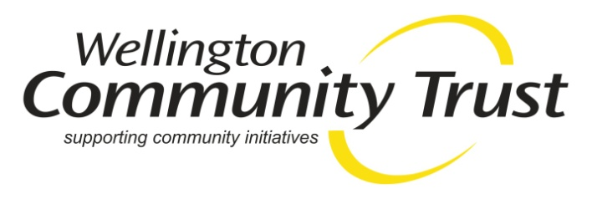
JOB DESCRIPTION

JOB TITLE: Administration Officer

Status: Fixed term contract, offered for three years

Hours: Three days per week (18 - 22.5 hrs) with flexibility to work over four days, if preferred.

Location: Wellington CBD

Remuneration: $25 p/h

About the Wellington Community Trust
WCT is an independent philanthropic funder. We offer funding to not for profit organisations active in the Wellington region – from Otaki down the Kapiti Coast to Porirua, Wellington and the Hutt Valley. WCT is governed by a Board of ten Trustees who make the granting decisions. We have a small staff team who receive funding applications, assess those applications and make grant recommendations to the board.
Our vision is: Engaged people, connected communities and sustainable environments across the Wellington region
Our mission is: To prudently manage and effectively distribute the Trust’s funds to enhance people’s lives and the environment of the Wellington region.

These values underpin our work:

- Social justice and equity
- Diversity
- Culture
- Creativity and innovation
- Sustainability
- Collaboration
- Transparency

PURPOSE OF POSITION
To provide administrative support to the Chief Executive, the Board and other WCT staff as required to enable the Trust to operate efficiently and effectively.

REPORTING
The position reports to the Chief Executive of Wellington Community Trust.

PRIMARY OBJECTIVES
- To administer the online Grant Registration and Application process
- To provide administrative support to the CEO and the Funding and Engagement Manager
- To assist with the preparation of reports and recommendations for the Board in accordance with approved policy and associated documents.
- To manage the electronic and physical filing of Trust documents in accordance with best practice and to maintain accurate records and completion of paperwork and follow-up actions.
- To provide administrative support for Board meetings, including preparation and distribution of Board Papers and recording of accurate Minutes of Board and Committee meetings.
- To provide assistance to the Chief Executive and other WCT staff with general administrative duties as required.

KEY RESPONSIBILIITIES

Chief Executive support
- Provide administrative assistance and support for the Chief Executive as required
- Organise travel and accommodation arrangements for CEO as needed
- Coordinate diary management including invitations to community events and meetings
- Provide administrative assistance and secretariat support for the Combined Community Trust group and maintain their shared Folder.

Grant Applications
- Assist with processing on-line applications and user registrations.
- Assist with all enquiries to the Trust and provide excellent customer service.
- Provide advice and support for applicants and potential applicants on the application process.

Records and Filing – maintaining the Trust records
- Assist with the development and on- going maintenance of the electronic file structure.
- Keep electronic and physical records and files up to date and accurate to meet legal and audit requirements.

Awards, Events and Ticketing

Assist with the annual Community Awards as required.

Assist with the planning and organisation of any community workshops.
- Manage and coordinate the distribution and recording of donated tickets to community groups.

Board support
- Assist with the preparation and distribution of Board Papers.
- Assist with recording the minutes of Board and Committee meetings.
- Coordinate travel requirements of Trustees as required
- Maintaining the Board papers in shared Board Folder.
- Managing invitations to Board members for community events.

General Administration Support
- Coordinate stationery orders within the office
- Arrange for courier pickups and deliveries as needed
- Organise catering for meetings and events as needed

Key Relationships:
The Administration Assistant will develop a good working relationship with WCT staff, Trustees, contractors and other external stakeholders.

WCT | External
- Chief Executive  - Community Engagement and  Funding Manager  - Fluxx data and Communications coordinator  - Trust Accountant  - Trustees | - Community Groups  - Strategic Partners  - Local and central government agencies  - Other funders  - Website provider  - Printing agencies  - Auditors

PERSON SPECIFICATION
The successful person will have the following skill set and expertise –

- Advanced technology and office administration skills.
- Experience in minute taking and providing secretariat support to a Board
- An awareness and interest in community issues.
- Excellent oral and written communications skills.
- “Can do” attitude.

